**DOUBLING THE VILLAGE INCOME BY DAIRY FARMING**

**1.1 INTRODUCTION**

We are now more aware than ever of the impact human activities have on the environment and other species. This awareness has brought criticism, some of it well deserved, on the agricultural industry, including dairy farming. It now seems an appropriate time to ask ourselves just how important dairy farming is.

Dairy farming plays a vital role in many local economies and in global economics. More areas of the world are also becoming increasingly reliant on the dairy industry as a source of nutrition. While there are areas for improvement, dairy farming continues to have a crucial role in today's world.

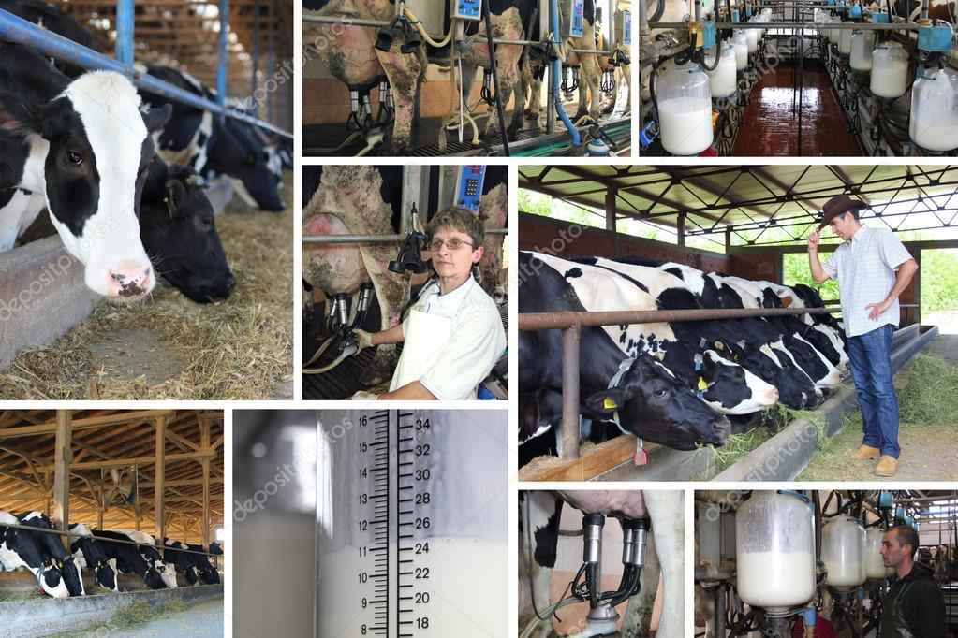

Image 1: DAIRY FARMING

It is far too easy to criticize dairy farms for being unsustainable or cruel to the cows without being aware of the reality and bigger picture. In this article, we will seek to highlight just how essential dairy farming truly is while also being honest about where the dairy farmers can could improve.

**1.1.1 WHAT IS DAIRY FARMING ?..**

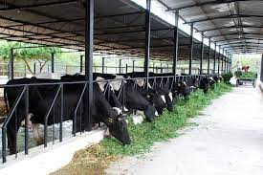

Image 2: DAIRY FARM

Dairying, also called dairy farming, branch of agriculture that encompasses the breeding, raising, and utilization of dairy animals, primarily cows, for the production of milk and the various dairy products processed from it.

Milk for human consumption is produced primarily by the cow and the water buffalo. The goat also is an important milk producer in China, India, and other Asian countries and in Egypt. Goat’s milk is also produced in Europe and North America but, compared to cow’s milk, goat’s milk is relatively unimportant. Buffalo’s milk is produced in commercial quantities in some countries, particularly India. Where it is produced, buffalo’s milk is used in the same way as is cow’s milk, and in some areas the community milk supply consists of a mixture of both.

Dairy plays a significant part in numerous aspects of Indian society, including cuisine, religion, culture, and the economy. India has the world's largest dairy herd with over 300 million bovines, producing over 187 million tonnes of milk. India is first among all countries in both production and consumption of milk. Most of the milk is domestically consumed, though a small fraction is also exported.

Dairy farming is a class of agriculture for long-term production of milk, which is processed (either on the farm or at a dairy plant, either of which may be called a dairy) for eventual sale of a dairy product. Dairying is an important source of subsidiary income to small/marginal farmers and agricultural labourers. In addition to milk, the manure from animals provides a good source of organic matter for improving soil fertility and crop yields. The gobar gas from the dung is used as fuel for domestic purposes as also for running engines for drawing water from well. The surplus fodder and agricultural by-products are gainfully utilised for feeding the animals. Almost all draught power for farm operations and transportation is supplied by bullocks. Since agriculture is mostly seasonal, there is a possibility of finding employment throughout the year for many persons through dairy farming. Thus, dairy also provides employment throughout the year. The main beneficiaries of dairy programmes are small/marginal farmers and landless labourers

In India, dairy farming is closely associated with agriculture. Originally, dairy farming was looked at as a family business, passed down from one generation to the next. However, as time passed, it entered a new era where things became much more organized and technologically advanced. Thus, dairy farming soon turned out to become a much more profitable sector.

**1.1.2 SIGNIFICANCE OF THE DAIRY SECTOR IN INDIA**

**Significance of dairy farming are as follows:**

* **Tackling Agricultural Uncertainties**: Farmers keep 2-5 milk animals for livelihood. They provide great support to them, especially during drought and flood. Further, dairying is not a seasonal occupation in nature, like agriculture.
* **Nutritional Support:** The milk and associated products have immensely helped India in reducing the malnutrition and undernourishment levels in the country. Thus, the dairy sector is indispensable for meeting the nutritional requirement of the country’s rising population.
* **Employment Generation**: It is a significant contributor to farmers’ income as approximately 70 million farmers are directly involved in dairying.
* **Reduces Import Bill**: **Operation Flood (also called as White Revolution)**converted India from a milk importer to the world’s largest producer.

The program launched in 1970 and adopted a multi-pronged approach. This included tax incentives, food quality standards, subsidies on inputs, infrastructure provisions such as cold chain and electrification.

All this helped in reducing import bills and made India an exporter. The country exported dairy products worth $187 Million in 2019-20.

**1.2 LITERATURE SURVEY**

Dairying contributes significantly to the livestock sector in terms of share in gross value added and animal population. The dairy farming in India has shown remarkable development in the past decade and India has now become world largest producers of milk accounting for 20% of world production. In 2016-17 India producing 163.7 million tonnes of milk with the growth rate of 5.3 % providing per capita availability of 352 gram/day (BAHS, 2017). As per 19th livestock census India possesses about 118.59 million milch dairy animals, cattle and buffalo account for 37.28% and 21.23% of the livestock population with 190.90 and 108.70 million in numbers respectively. According to estimates of the Central Statistics Office, the value of output livestock sector at current prices was about 5,91,691 crore which is about 28.5% of the value of output from agricultural and allied sector. At constant prices the value of output from livestock is about 29% of the value of the output from total agriculture and allied sector. Within Livestock sub-sector, dairying constitutes the major share about 67% in value of outputs from agriculture (Jaiswal et al., 2018). Livestock sector provides employment to 8.8% of population which largely comprises of landless and unskilled population.

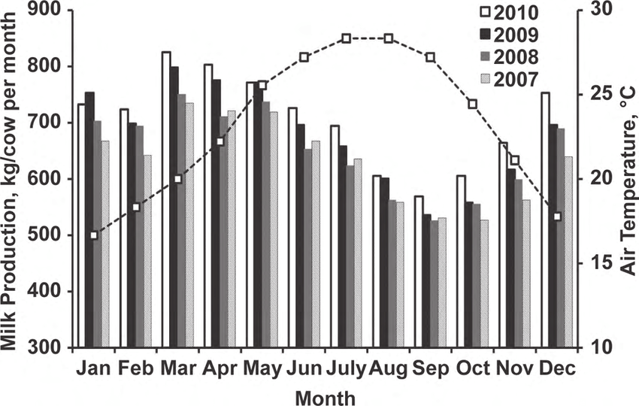

Image 3: BAR CHART SHOWING MILK PRODUCTION

The milk production envisaged to be 254.55 Million MT by 2021-22 and 300 Million MT by 2023-24 from existing 163.7 Million MT and will be requiring an annual growth rate of 9.2%. This would lead to increase in per capita availability of milk from current level of 352 grams/day to 515 and 592 grams/day in 2021-22 and 2023-24 respectively. To achieve the desired milk production targets, average In-milk animal productivity would also be required to grow annually at the rate of 4.7% to 6.14 Kg/day by 2021-22 and 6.7 Kg/day by 2023-24. It has been envisaged that by the end of 2021-22 and 2023-24 the surplus milk available with farmer will be 60% of total production (NAP vision 2022).

The ability of farms to produce milk sustainably is closely related to dairy cow longevity, i.e., the length of productive life. However, longevity is a very complex feature that depends on all the aspects of the lifespan of a cow and there is no standard definition nor metric to measure it. Measuring longevity is important because it influences the profitability and the environmental impact of farms as well as the welfare of the animals. The objectives of this paper were to review metrics used to measure longevity and describe its status among high milk-producing countries. Increasing dairy cow longevity would imply that an animal has an early age at first calving and a long and profitable productive life. Combining age at first calving, length of productive life, and margin over all (available) costs provides a complete evaluation of longevity. This paper also shows that dairy cow longevity has decreased in most high milk-producing countries over time, which confirm the concerns voiced by the dairy industry and other stakeholders. Increasing cow longevity would reduce health costs and increase cow profitability while improving both animal welfare and quality of life, contributing to a more sustainable dairy industry.

|  |  |  |  |  |  |
| --- | --- | --- | --- | --- | --- |
| **Year** | | **2016-17** | **2021-22** | **2022-23** | **2023-24** |
| **Milk production (MMT)** | | 163.7 | 254.5 | 276.3 | 300.0 |
| **Milk production from cattle and buffalo(MMT)** | | 162.8 | 245.6 | 266.6 | 289.4 |
| **No. of bovine in milk(in Million)** | | 91.58 | 109.62 | 113.64 | 114.68 |
| **No. of farmer member owing bovine(in**  **million)** | **Cooperative** | 16.08 | 19.29 | 20.01 | 20.75 |
| **Private** | 6.45 | 13.60 | 15.03 | 16.44 |
| **Producer company** | 0.40 | 1.20 | 1.40 | 1.50 |
| **Un organized** | 57.07 | 45.91 | 43.56 | 41.31 |
| **Total** | 80.00 | 80.0 | 80.0 | 80.0 |
| **Milk yield/ animal/day(Litter)** | | 4.87 | 6.14 | 6.43 | 6.73 |
| **Milch animal per farmer (in nos.)** | | 1.13 | 1.35 | 1.40 | 1.45 |
| **Litter of milk/farmer/day** | | 5.58 | 8.41 | 9.13 | 9.91 |
| **Marketable milk(52% of milk sold per farmer) (Litter/day)** | | 3.35 | 5.05 | 5.48 | 5.95 |
| **Milk sold per farmer (Litter/month)** | | 100.38 | 151.37 | 164.33 | 178.40 |
| **Procurement price (Rs./ Litter) ( SNF 9% and Fat 6%** | | 33.80 | 43.14 | 45.29 | 47.56 |
| **Sale price (Rs./ Litter) ( SNF 9% and Fat 6%** | | 48.30 | 61.64 | 64.73 | 67.96 |
| **Farmer income( @20% of procurement price) Rs./ Litter** | | 6.76 | 8.63 | 9.06 | 9.51 |
| **Average income per month per farmer (Rs.)** | | 679 | 1306 | 1489 | 1697 |

Table 1: Target under action plan for dairy development and income

**1.3 CHALLENGES OF SUSTAINABLE DAIRY FARMING**

The Indian dairy sector is different from other dairy-producing countries as emphasis is placed on both cattle and buffalo milk. In order to achieve greater profitability, quality standards need to be improved. The following are some of the practical dairy farming challenges in India.

1. **Shortage Of Animal Feeds And Fodders**: At present, India faces a shortage of 23.4 percent for dry fodder, 11.24 percent for green fodder, and 28.9 percent for concentrates (IGFRI Annual Report, 2019). Currently, the country produces fodder on only 5 percent of its cultivable land. National Agricultural Technology Programme (NATP) data and the 19th livestock census revealed that India is facing fodder shortage and that the quality of the feed available is poor and does not meet necessary feeding standards of animals. With the increasing popularity of high breed animals, there is a huge demand for good quality feed and fodder to meet the dietary requirements of milking animals. There are an excessive number of unproductive dairy animals that are competing for feed and fodder with productive dairy animals. In the recent years, grazing areas have been shrinking significantly due to industrial development, which has resulted in a shortage in feed and fodder supply. The small and marginal farmers and agricultural labourers engaged in the dairy farming do not have the capability to purchase adequate feeds and fodder, therefore their animals remained under fed. In standard dairy production systems, feed costs account for up to 70% of total costs. Consequently, the dairy farming profitability is affected by high-cost feeding.
2. **Lack Of High Yielding Germplasm**: Low productivity and yield of Indian dairy animals is the major challenge face by the Indian farmer. Although India possesses a large livestock population and is the world’s largest producer of milk; however, productivity of dairy animals has been extremely low, turning this vital asset into a liability for the poor. More than 60% of rural households keep large ruminants, mostly for milk production and partly for draught purpose from bullocks. However, the average milk yield of Indian dairy animals is significantly low.

|  |  |  |  |  |  |  |
| --- | --- | --- | --- | --- | --- | --- |
| Exotic Cows | Crossbred Cows | Indigenous Cows | Non-Descript Cows | Indigenous Buffaloes | Non-Descript Buffalo | Goat |
| 11.67 | 7.85 | 3.85 | 2.50 | 6.34 | 4.35 | 0.45 |

Table 2: Average Yield per animal during 2018-19 (Kg/Day) (DAHD, 2019)

1. **High Cost Of Milk Production:** The cost of milk production in India needs to be reduced in order to get good income from milk. The main reason of the high cost of milk production is the low average milk yield of Indian cattle, i.e. 987 kilograms/year compared to 6273 kilograms/year in Denmark, 5289 kilograms/year in France, 5938 kilograms/year in Canada, 5462 kilograms/year in the United Kingdom, 7038 kilograms/year in the United States, and 11000 kilograms/year in Israel. As a result, farmers in other countries spend much less than farmers in India. Therefore, this high yield has been achieved through proper feed, water management, and housing, in addition to superior germplasm.
2. **Unorganized Indian Dairy Sector:** The most fundamental feature of the Indian dairy industry is that it is still mostly unorganized. Only 18-20% of India’s total milk production is handled in the organized sector. The unorganized sector has still not integrated into the modern processing infrastructure. Even though India is the world’s largest producer and consumer of milk; however, per capita consumption is much lower than that of developed countries. India is neither an active importer nor an active exporter in the dairy sector. The main challenges faced by the dairy industry are procurement and transportation. The procurement of fresh milk is the most essential part of the dairy industry. Due to the perishable nature of milk, it is not possible to procure milk beyond a 200 km radius. Cold storage and supply chain difficulties affect India’s dairy industry.
3. **Poor Adoption Of Technology By Indian Dairy Farmer:** There are already proven high-yielding varieties of fodder and technologies for feeding livestock such as urea-molasses treatment, silage and hay making. Unfortunately, these technologies are very poorly adopted by many farmers in most states. According to the Indian Ministry of New and Renewable Energy (MNRE) report, on an average, India produces 500 million tons of crop residue each year. The same report shows that most of this crop residue is used in domestic and industrial applications as fodder as well as fuel. Despite that, there is still a surplus of 140 million tons, of which 92 million tons are burned every year and could potentially be used as animal feed.

Artificial Insemination (AI) is the most affordable and convenient method for dispersing improved genetics to farmers’ doorsteps. India started to use Artificial Insemination (AI) on 1970 onwards. However, AI coverage of bovines is about 30%, ranging from 71% to less than 1% in several states. Consequently, 65 percent of animals are still bred naturally either because the services are not available at the farmers’ doorstep or because of poor efficacy of frozen semen or non-availability of well-trained AI technician.

1. **High Economic Losses Of Dairy Farmer Due To Diseases:** Farmers have a huge financial burden due to animal diseases. The higher quality of germplasm that has been achieved via the cross-breeding program has resulted in an increase in the susceptibility of these animals to a wide range of diseases, including exotic diseases. Inadequate vaccination coverage is continuously resulting in economic losses attributed to a wide variety of animal diseases. It is difficult to include accurate estimates of the losses caused by the various diseases since it is impossible to record all diseases in all locations.

The direct losses evaluated based on reported diseases suggested that average yearly economic losses because of Haemorrhagic Septicaemia (HS), Foot and Mouth Disease (FMD), Brucellosis, Peste des Petits Ruminants (PPR), were in tune of Rs. 5255 crores (2014), Rs. 20000 crores (2016), Rs. 20400 crores (2015), and Rs. 2417 crores (2016), respectively (Singh, 2019). It was estimated that farmers in India suffer direct losses of over 50,000 crores per year as a result of diseases that may be completely avoided with immunization. The government of India, along with state governments, spends an equal amount of money on vaccination against these diseases, resulting in a loss of nearly one lakh crore rupees due to non-reporting diseases, substandard vaccines, ineffective vaccination, and lack of education of livestock farmers etc. (Singh, 2019).

1. **Inadequate Veterinary Facility In Dairy Sector:** The Indian dairy sector is suffering due to inadequate infrastructure facility. The National Commission on Agriculture (NCA)-1976 recommended that one veterinary institution be established for every 5,000 cattle units (one cattle unit =1 cow / 1 buffalo /10 sheep / 10 goats / 5 pigs / 100 poultry) to maintain effective veterinary health care. According to VCI, India has 67651 veterinarians, while demand is between 1.1 to 1.2 lakh.

As a result of this inadequacy, farmers received poor and insufficient veterinary services. From 1970 onward, India started to use Artificial Insemination (AI), as a reproductive technology in order to improve cattle breeds and milk production. However, in the last fifty years, due to several constraints, the average conception rate through AI is not going beyond 30-40 percent at field level.

1. **Inadequate Extension Services:** Providing technical services to animals, supplying technical inputs, and educating livestock farmers are the three components of livestock service delivery to the farmers. The provision of animal health services includes vaccination, deworming, breeding and disease management, vaccines, medicines, semen, AI guns, syringes and needles, etc., have to be provided as technical inputs.

In order to obtain the above services and, to a certain extent, to obtain technical inputs, livestock farmers must rely on vets or para-vets. Thirdly, livestock farmers need to be educated on various animal husbandry managements viz. feeding, vaccination, disease management, breeding, etc. unfortunately, this component is grossly neglected. In addition to transfer of technology and strengthening of various infrastructure and support services, extension services need to focus on building the capabilities .

**1.4 CHALLENGES OF SUSTAINABLE DAIRY FARMING IN VISITED VILLAGE**

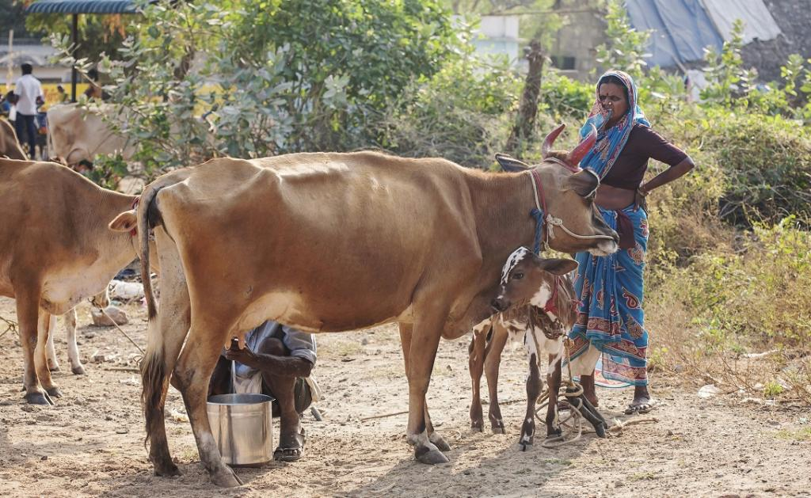

Image 4: DAIRY FARMER COLLECTING MILK

1. **Challenges in The Dairy Sector Business:** India has a unique pattern of production, processing and marketing/consumption of milk, incomparable to any large milk producing country. India is the world’s largest milk producer and consumer of dairy products, consuming almost 100% of its own milk production. The Indian dairy sector is different from other dairy producing countries as emphasis is placed on both cattle and buffalo milk. In order to achieve greater profitability, quality standards need to be improved. Following are some of the practical dairy farming challenges in India.
2. **Shortage of feed/fodder:** There is an excessive number of unproductive animals which compete with productive dairy animals in the utilisation of available feeds and fodder. The grazing area is being reduced markedly every year due to industrial development resulting in shortage of supply of feeds and fodder to the total requirement. Ever increasing gap between demand and supply in feeds and fodder limits performance of dairy animals. Moreover, provision of poor quality of forage to dairy cattle restricts animal production system. The low capability of purchasing feeds and fodder by the small and marginal farmers and agricultural labourers engaged in dairy development result in inadequate feeding. Non-supplementation of mineral mixture results in mineral deficiency diseases. High-cost Feeding reduces the profits of the dairy industry.
3. **Breeding system:** Late maturity, in most of the Indian cattle breeds, is a common problem. There is no effective detection of heat symptoms during oestrus cycle by the cattle owners. The calving interval is on the increase resulting in a reduction in efficiency of animal performance. Diseases causing abortion leads to economic loss to the industry. Mineral, hormone and vitamin deficiencies lead to fertility problems.
4. **Health:** Veterinary health care centres are located in far off places. The ratio between cattle population and veterinary institution is wider, resulting in inadequate health services to animals. No regular and periodical vaccination schedule is followed, regular deworming programme is not done as per schedule, resulting in heavy mortality in calves, especially in buffalo. No adequate immunity is established against various cattle diseases.
5. **Hygiene Conditions:** Many cattle owners do not provide proper shelter to their cattles leaving them exposed to extreme climatic conditions. Unsanitary conditions of cattle shed and milking yards, leads to mastitis conditions. Unhygienic milk production leads to a reduction in storing quality and spoilage of milk and other products.

**1.5 ECONOMIC CONTRIBUTION**

The Indian dairy industry has developed reliably as far back as the White insurgency of the 1970s, making India, the world's biggest producer of milk with 17% worldwide offer. With a yearly production of 146 million tons of milk India creates roughly USD 70 Billion of income. The Indian dairy market is required to twofold inside the following decade, basically determined by more than 15-20% growth in worth included dairy portion. To use this high growth potential and to satisfy the rising need, a maintainable and solid dairy farming base will be basic.

For accomplishing this, it ends up basic to address key difficulties looked by the industry, for example, low creature yields, incapable rearing, ill-advised feed and grain the board, lacking veterinary consideration, poor farm the executives and low monetary incorporation among others. With dairy farming in India commanded by smallholder farmers, with a normal group size of fewer than 2, it turns into all the all the more testing to address these issues, in the particular setting of making small holder dairy farming all inclusive focused. Notwithstanding the magnificent backend work being finished by private sector and agreeable, proper farm level approaches should be created by the Government to guarantee maintainable dairy advancement through existing socio-economic elements and resource points of interest. Compound Annual Growth Rate (CAGR) and Dairy Farming in India. India's dairy industry is relied upon to keep up 15 percent exacerbated yearly growth (CAGR) more than 2016-20, and achieve estimation of Rs 9.4 trillion on rising industrialism, a report said.

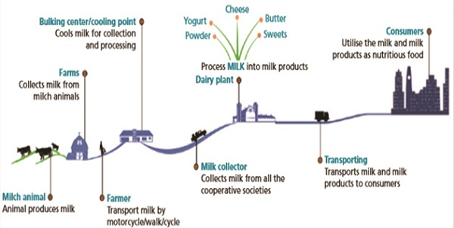

Image 5: MILK FROM PRODUCERS TO CONSUMERS

"India's dairy industry is worth Rs 5.4 trillion by worth, having developed at 15 percent CAGR during 2010-16. Proceeding, the dairy industry is relied upon to keep up 15 percent CAGR more than 2016-20, and achieve estimation of Rs 9.4 trillion on rising industrialism". India has advanced from being insufficient in milk production at 20 million MT in 1970 to turning into the world's biggest milk producer at 160 million MT, representing 18.5 percent of worldwide milk production.

Further, India is relied upon to rise as the biggest dairy producer by 2020, the report said. The Union government actualized the Central Scheme National Dairy Plan - Phase 1 during 2012-17 to improve productivity of dairy cooperatives through a few information exercises. Speculations by private players in the residential dairy sector are additionally expected to further increase milk productivity, it clarified. Proceeding, India's milk production is required to beat worldwide production.

**1.6 PLANS TO DOUBLE THE INCOME:**

These some plans where we can double the income

* Implementing Pasteurization
* Processed Milk Products
* Gobar as fuel
* Introducing online platform

1. **Implementing Pasteurization:**

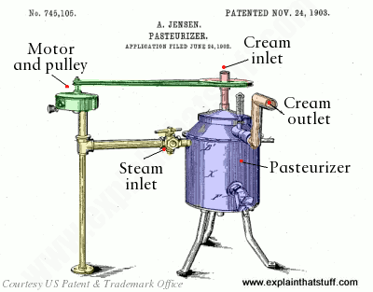 Its history began over 150 years ago. In 1864, Louis Pasteur developed the heat treatment process called pasteurization while attempting to stop harmful bacteria from growing in many different foods. He discovered that placing milk under extreme heat for a short period of time kills harmful bacteria and dramatically slows the growth of future bacterial risks.

Image 6: Pasteurization Technique

We get the term “pasteurization” from Pasteur and his discovery. The procedure commonly uses stainless-steel plates to heat cold, raw milk to 161.5°F for 15 seconds before immediately cooling the milk to its original temperature of 39°F. The heat kills bacteria responsible for diseases like typhoid fever and tuberculosis and bacteria like listeria and salmonella. While making milk safe to drink where people want things to be hygiene. Pasteurization also increases milk’s shelf life and reduces spoilage and wastage of milk.

1. **Processed Milk Products:**

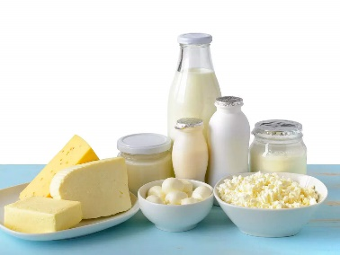 Proper utilization of dairy-product has direct impact on the economy condition of the farmers. If the daily amount of fresh milk is limited, it is more economical to process the milk into less perishable products, store them and sale later in larger quantities. Generally the price of processed milk products is high as compared to raw milk. If a farmer is reluctant to sale the milk because of getting lower price then he can take initiative to sale processed dairy products such as ghee, paneer, curd, butter, butter milk etc. Sometimes, there may not be availability of market nearby so in such cases sale of preserved products may bring greater financial gain.

Image 7: Milk Products

1. **Dairy Wastes:**

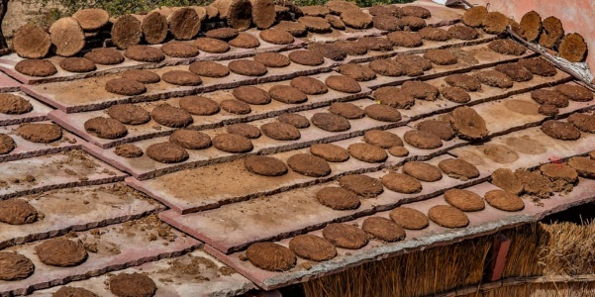 Saving money is a kind of earning money. Cow dung has been considered as a Gold Mine, along with cow urine it can be used as fertilizer in the field of agriculture and energy resource to save money. Besides, cow dung can be used in making money from Panchgavya, Gau-mutra ark, various medicines and cosmetics. In addition to that government of India implemented Gobar Dhan scheme, the online trading of cow dung is one of the way to generate wealth from cow dung. These wastes are not just wastes, it adds to the economy of farmers to a large extent

Image 8: Dried Cow Dung

* **Cow Dung:**Cow dung that can be dried and sold as cow dung manure. You can use dung drying machines to dry the cow dung and sell the organic manure in the market.
* **Cow Dung Slurry:**This slurry is a mixture of cow urine, cow dung, and water. You can use the water from the cowshed that is collected after bathing the cows. This mixture can easily be sold in the market. The slurry can be used as natural manure, biofertilizer, or even as a biopesticide.
* **Gonandajala (Obtained From A Dead Cow):**Gonandajala is a fluid that can be formed by a cow’s corpse. This fluid has a high amount of nutrients that can be mixed in water and used as an organic fertilizer. This fertilizer is found to boost soil productivity.
* **Cow Urine:**Cow urine is in great demand with the rise of organic farming practices in the country. We came across a few dairy farmers based in Jaipur and Gujarat who have created an additional income stream by selling cow urine. Many organic farmers use cow urine as an alternative to chemical pesticides. People also use the urine of desi cows in various rituals.

1. **Implementing Online Platform:**

 **One can sell dairy online and there is  already a large and thriving industry of online dairy distributors.** Now is the perfect time to sell online according to the aforementioned statistics. We have COVID-19 to thank for the recent surge in successful eCommerce marketplaces. Even with the traditional brick-and-mortar shop still standing, a majority of patrons prefer the experience and conveniences online shopping provides. In addition, we're seeing D2C sales surpass in-store sales. As you can see, starting an online dairy shop is a worthy investment. However, there are some important things to know before you jump in head-first. This includes knowing both the benefits and challenges of selling dairy online.

Image 9: Online Marketing

* **Obtain Your Food Handlers Certification:** Regardless of where you reside, if you handle perishable goods it is a requirement to have a food handler’s certification. This shows that you know how to keep your product consumption-safe and garner government and customer trust in your business. It's also a good idea to purchase eCommerce business insurance and get your wholesale license. For a lot of businesses, neither is required. However, they'll provide you with additional layers of protection.
* **When obtaining food handler’s cert, you'll learn that proper eCommerce packaging is required when selling online.**You have to use specific labeling and packaging for your products; legal issues are sure to follow if not. Correctly packaging and labeling your products includes a comprehensive ingredient list, proper label sizes, and potential allergies.
* **Finally, learn state's sales tax requirements.**Sales tax does vary by state, so you'll need to follow state-specific guidelines. However, if you use an eCommerce platform like BlueCart, sales tax is calculated automatically.

**1.7 ADVANTAGES**

* Nowadays the milk production industry is the most desirable industry all over the world. Milk and milk products have huge demand in the market. This is the main benefit to start a commercial dairy cow farming business.
* Demands for milk and its products will never reduce because both vegetarians and non-vegetarians will have milk.
* You don’t need to worry about marketing the products because it is a traditional business so you can sell the products easily.
* it is an eco-friendly business.
* You can increase dairy production through mechanization instead of using labors.
* Proper planning, management and taking good care of your animals will provide maximum profit. So, you will get a great source of income.

**1.8 CHALLENGES WHILE IMPLEMENTING PLANS**

* **Fragmented Supply Chain:**The fundamental challenge in dairy is maintaining quality and quantity within a diversified supply base. Due to its perishable nature, dairy requires more complex supply chain operations and logistics to ensure freshness and safety.
  + The sector also witnesses adulteration practices and overuse of antibiotics to boost production.
* [**Price Sensitivity**](https://blog.forumias.com/dairy-sector-in-india-needs-urgent-attention/)**:** Milk producers are highly susceptible to even minor shocks.  For instance, small changes in the employment and income of consumers can leave a significant impact on milk demand.
* **Unorganised Nature:** The majority of cattle raisers are unorganised unlike sugarcane, wheat, and rice-producing farmers. This nature further inhibits the creation of political clout to advocate for their rights.
* **Data Deficiency:** There is no official and periodical estimate of the cost of milk production. Even though, the value of milk produced outweighs the combined value of the output of wheat and rice in India.
* **Poor Returns**: There is no MSP (Minimum Support Price) for milk unlike 24 major agricultural commodities in the country including wheat and rice. Further, dairy cooperatives are not a preferred choice for landless or small farmers.
  + The cooperatives adopt a fat-based pricing policy which is 20 to 30 % less than the price in the open market.
  + Further, dairy cooperatives buy more than 75% of milk at its lower price band.
* **Competition From Alternatives:** The traditional cow and buffalo milk is shunned by some consumers for more eco-friendly alternatives like ‘Soy Milk’ or ‘Almond milk’. They believe that the carbon footprint of plant-based milk products is much lesser than the traditional dairy products.
* Livestock diseases like FMD, BQ, HS and mastitis acts as negative influence on the production system results, low income. Mastitis is considered as major economic important disease in India, according to one study the total annual economic losses due to mastitis was calculated is 7165.51 crore rupees (Bansal and Gupta, 2009). Inadequate quantity and quality of feeds affects dairy farming system. As per estimate the deficit of dry fodder, concentrates and green fodder currently is 10, 33 and 35 % (Planning commission, 2012) respectively. Low productivity of milk animals, poor access to breeding, seasonality in production, limited use of manufactured cattle feeds, lack of good quality animal husbandry and farming practices, animal health and credit services and high cost of Artificial Insemination (AI) services are the other issues.

**1.9 SOLUTIONS TO OVERCOME CHALLENGES**

* **Breeding System:** Experts have identified two issues with Indian cattle breeds: a) most of the breeds require prolonged period to attain maturity and b) they usually have increased calving interval. These factors affect efficiency of animal performance.
* **Education And Training:** Education and training on Good Manufacturing Practices is an essential requirement for the farm employees .
* **Animal Health:** Adequate Veterinary health care, proper vaccination and regular deworming need to be ensured for sustainable production.
* **Hygiene Conditions:** Unhygienic farming practice leads to disease of cattle and buffalo. This also leads to compromise in the quality of milk resulting in spoilage of both milk and milk products.

**1.10 BENEFITS**

* Women Empowerment: Women play a significant role in dairy production. They undertake a range of dairy management tasks, including feeding livestock, cleaning cowsheds, looking after calves, milking, milk processing and marketing. As per Agriculture situation in India (2017) the strength of women in Dairy has reached to the 70% of the total work force (about 44 lakh) of which 3,60,000 women are in leadership roles in village dairy cooperatives and 380 women on the boards of Union and State Federations.
* Increased Consumer: Today the dairy world is serving over 7 billion consumers and providing livelihoods for approximately 1 billion people which either live on dairy farms. The growing demand for milk and milk products offers opportunities for smallholders to enhance their income by increasing the efficiency of their milk production.
* **Boosting Other Sectors**: The dairy sector provides cow dung which is used as an organic manure for the agricultural sector. Further, the sector provides raw materials to manufacture processed foods. For instance, the whey protein powder is an extract from the watery portion of milk that separates from the curds during the cheese-making process.

**1.11 CONCLUSION**

Dairy farming is common in village. However it is not a high priority in the eyes of the farmers or the market. This low priority means that little is done on research in these areas due to lack of funds. Specific machinery and inputs for dairying are mostly imported and therefore very expensive, making dairy a marginal profit business. Most stakeholders agree that generic marketing and better loan facilities for setting up dairy farms may improve the situation; however, due to the lack of willingness to cooperate on these schemes because of the small market available, these ideas have not taken off, except to a small degree .

Dairying helps in rising income and employment among rural households. With a good strategy, well designed programmes, adequate resources and government initiatives, the country can achieve the goal of doubling farmer’s income by the year 2025. Strong measures will be needed to harness all possible sources of growth in farmer’s income within as well as outside agriculture sector. Here dairy farming play a significant role in doubling farmer’s income and it needs to maintain an annual growth rate of 5.3 % in milk Production. Farmers should be aware of recent technologies interventions and focus on keeping healthy animals for producing good quality and quantity of milk. Switching over to organic dairy farming and IFS is very good alternative for obtaining additional gains. In order to double the farmer’s income at individual level, it is imperative that in-milk animal productivity is enhanced further, milk price paid to farmers also need to be raised and develop more cooperatives. Thus dairy farming has that untapped potential whose improvement can help achieving the target.

**1.12 REFERENCES**

* Dairy Farmer from Andle village
* NAP Vision-2022, National Action Plan for dairy development, 2018, Department of Animal Husbandry, Dairying and Fisheries. Ministry of Agriculture, Govt. of India, New Delhi
* National Sample Survey Organization (NSSO), 2012, “Household Consumption of Various Goods and Services in India”: NSS 66th Round.” NSSO Report 541, Government of India, February
* National Sample Survey Organization (NSSO), 2013, “Some Characteristics of Agricultural Households in India”: NSS 70th Round.” NSSO Report 569, Government of India. New Delhi, January-December
* https://farmsnation.com/business/how-much-profit-do-dairy-farmers-in-india-earn/
* https://ijaast.com/publications/vol6issue2/V6I202.pdf
* https://www.pashudhanpraharee.com/challenges-solutions-of-dairy-sector-in-india/
* https://www.bluecart.com/blog/how-to-dairy